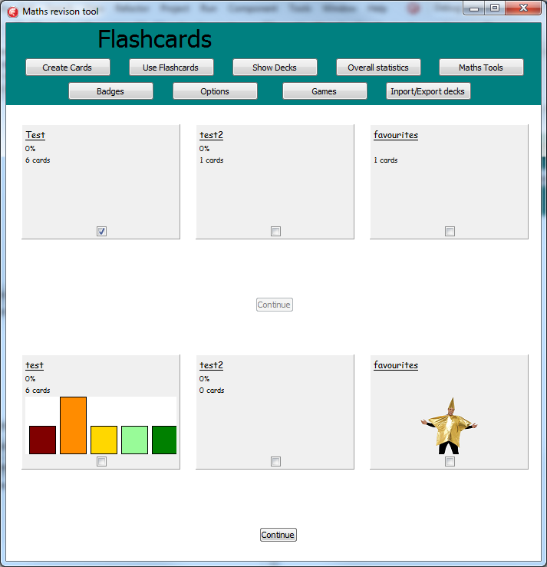

Lots of errors with parameters -needed dry runs

Adding more tables to see how an increase would work- discovered multiple errors with incorrect ids being used as they werent reset within a loop

Lots of errors with the order of 